**Major Activities Carried out By ASDDW**

**Addressing COVID – 19 and AMPHAN crisis:**

**Supporting Disabled women:**

Sunity, physically challenged women, was supported with an electrical sewing machine and cash grant of BDT. 3000/- (US$ 30) during covid-19 lockdown. The sewing machine was given by ASSDW, and Cash grant was given by Christian Aid & UN Women.

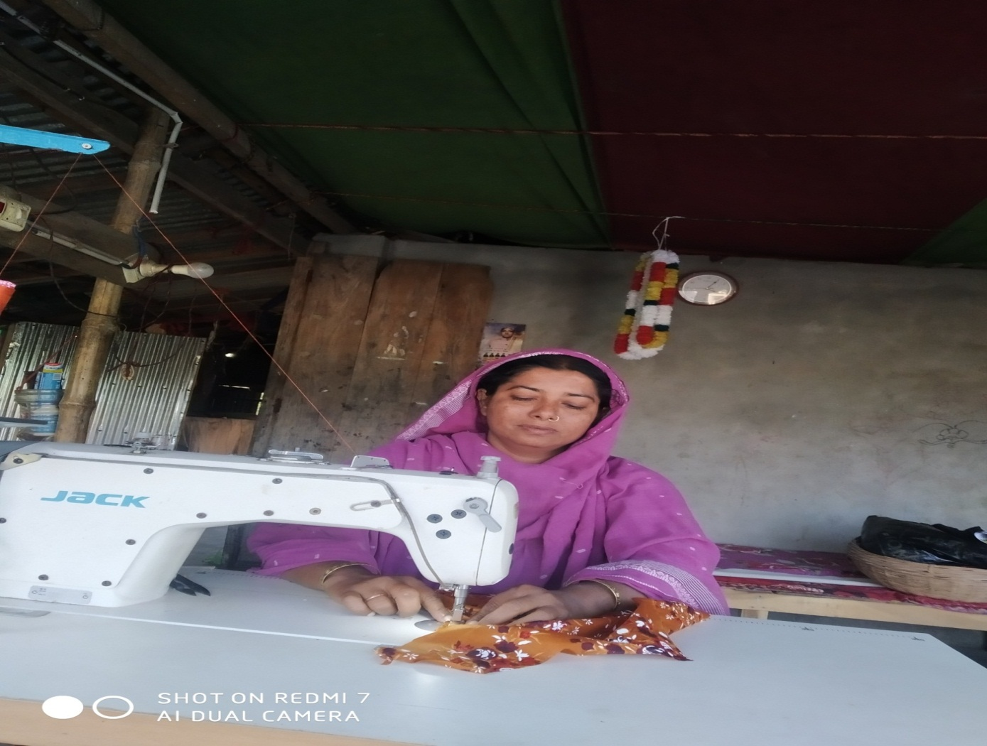

Physically Challenged Sunity is in her work.

**Food Distribution during COVID-19 Lockdown:**

Food Stuff and safety equipment's were distributed during COVID – 19 and cyclone AMPHAN. Devidwar Foundation, Cumilla, & SONNE International, Bangladesh office supported the activity.

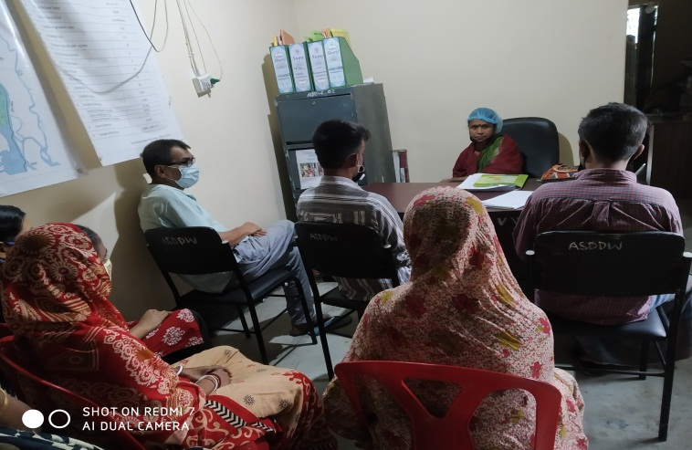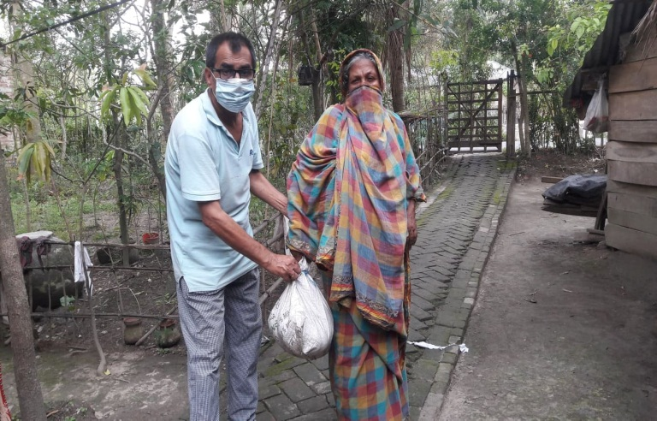

Food stuff distribution during COVID - 19 Lockdown

Volunteers meeting before food distribution

**Cash Incentives Distribution during COVID-19 & AMPHAN Crisis:**

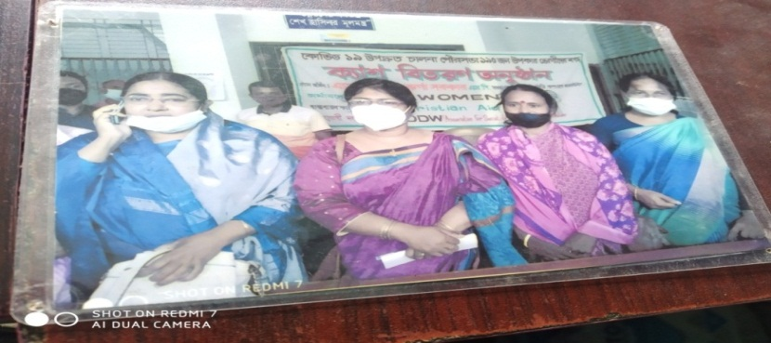During COVID -19 pandemic and AMPHAN cash grant was distributed among women beneficiaries. Cash @ Tk. 3000/- (USD 30) per person, was distributed electronically. Ms. Gloria Jharna, MP of reserve seat of Khulna and Upazila Parishad women Vice-Chair graced the cash distribution event. Total 300 women beneficiaries were given Cash Grant. The beneficiaries included sex workers (Dacope Brothel), Transgender, Dalit and poorest of poor Hindu and Muslims women. The support was given by UN Women

MP Ad. Gloria Jharna, Khadija Begum, Upazila woman Vice-chair &

Lipika Bairagi , ED of ASDDW are seen in the occasion

**Climate Resilient Activities (PAR Project):**

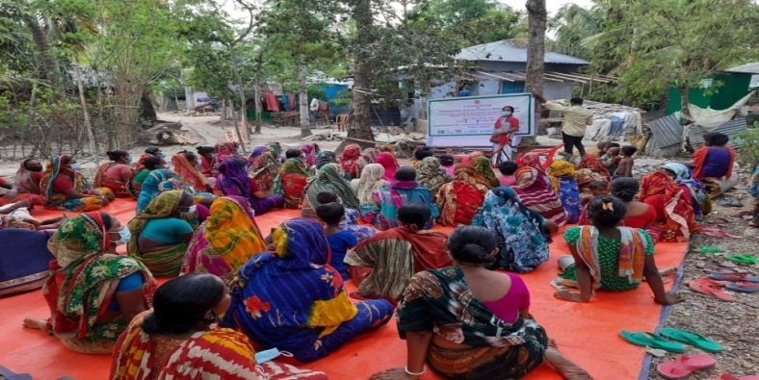**Courtyard Meeting:**

Dacope Upazila under Khulna district is very much vulnerable to cyclone. It has become as a yearly event here. It is found that women are the worst victims of this disaster. It needs to aware the women how to face the calamity so that lives & wealth may suffer less destruction. The activity is carried out by the support of Christian aid.

Court yard meeting to aware of disaster and its preparedness

**Vegetable Gardening:**

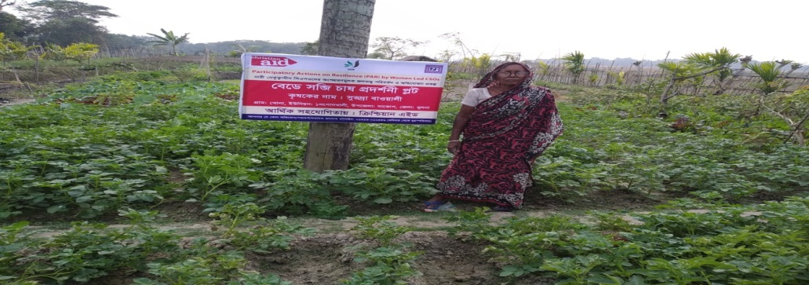Subhadra, a women was given capital support of Tk. 10,000/- to establish vegetable garden to grow vegetable year round. The aim of the activity is to produce vegetable year round for own consumption and at the same time to generate extra income selling it in local market places to support her family. Support was given by Christian aid under PAR program.

Subhadra at her Vegetable Grden

**Saline Tolerant Rice Cultivation:**

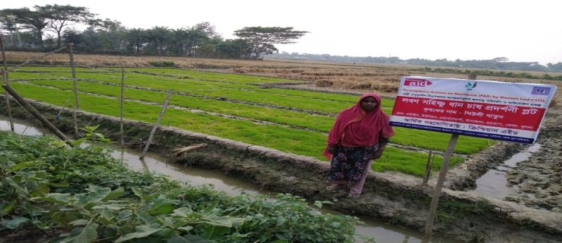Women farmer was given Tk. 10,000/- (USD 100) as capital support to cultivate saline tolerant rice using surface water stored n canal. The support was given by Christian aid, under PAR project.

Saline tolerant rice cultivation

**Livestock:**

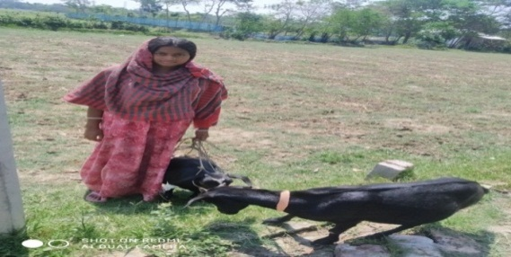Being common activity and completely for women of rural settings and profitable activity, women beneficiaries were given cash support to raise goat. The support was given by PAR project.

Goat rearer with her goats.

**Communication:**

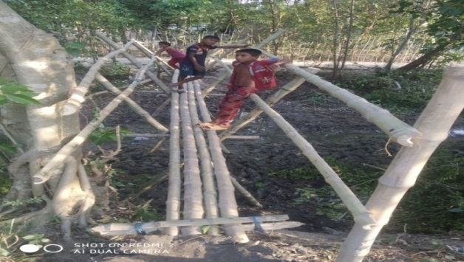Bamboo Bridge (Shako) is built to help commute local people across a canal, help women fetch water and children go to school safely. Christian aid under PAR project supported the activity.

Bamboo Bridge across a canal

**Embankment Protection Committee Meeting:**

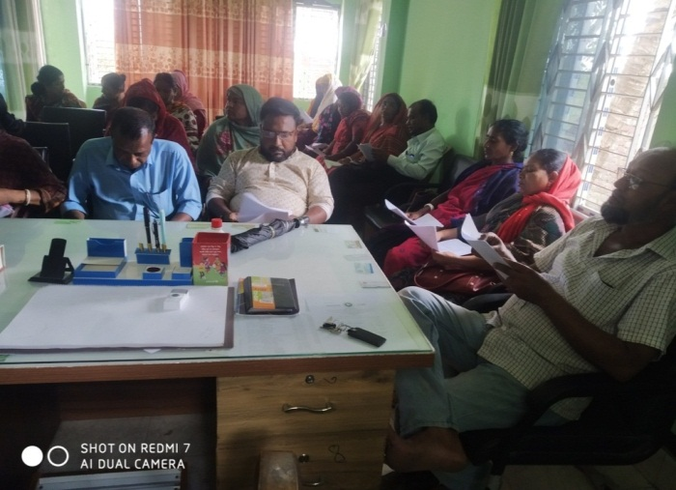To restrict saline intrusion, Dacope Upazila is surrounded by polders but all the polders are erosion prone. During cyclone, & tidal surge (in monsoon) these embankments may breach; it needs spontaneous repairing measure to save crop and wealth from flooding. This Embankments Committee takes urgent action to mend the breach developed before reaching govt. support. The PAR project has taken the initiative to increase women representatives in the committee and strengthening Committee activities. The activity is being carried out by the PAR project

Embankment protection committee meeting

**Union Disaster Management Committee (UDMC) Meeting**

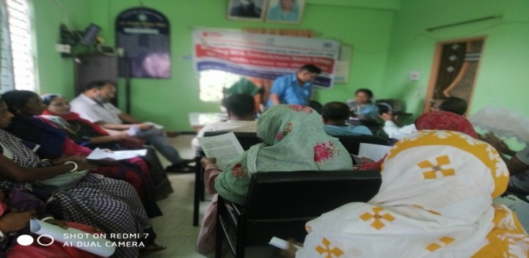PAR project facilitate to conduct UDMC meeting regularly that is important to mobilize people and resources during and after disaster such cyclone, flood etc. As the women are the prime victims of all the disasters thus it needs to increase participation of them in the UDMC. Under project we are able to increase women participation in the UDMC about 50% from 27% earlier. The activity is being carried out by the PAR project.

UDMC Meeting in Pankhali UP

**Rainwater Harvesting Plant:**

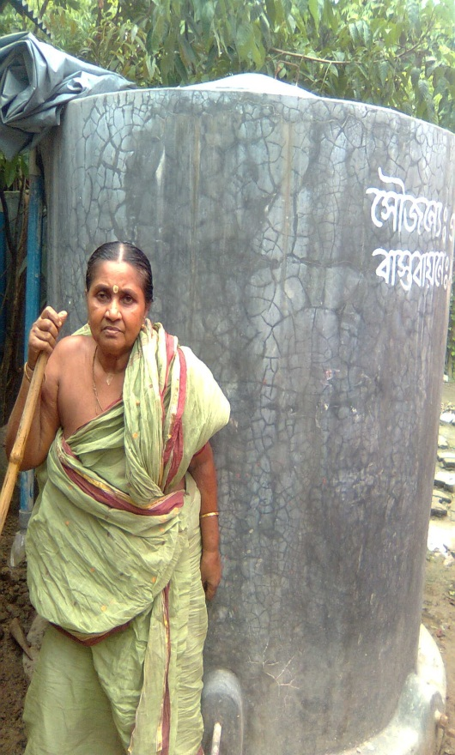To provide safe drinking water in saline prone local where both surface and ground water is saline, (beyond permissible level) household base RHPs were constructed in Chalna Municipality & Pankhali Union, under Dacope Upazila, Khulna. The support was given to women headed household and poorest of the poor households.

Rainwater Harvesting System

**Climate Change Adaptation Program:**

South-west coastal region of Bangladesh has excessive salinity both in surface and ground water. Thus, no irrigation is possible during lean season. Climate change has made it worst. ASDDW has introduced rainwater recharge technique called Agri-ASR to recharge rainwater stagnant in the field during monsoon and lifting it during lean season for irrigation. Agri-ASR facilitates women job creation in agricultural field during lean season when usually they remain unemployed.

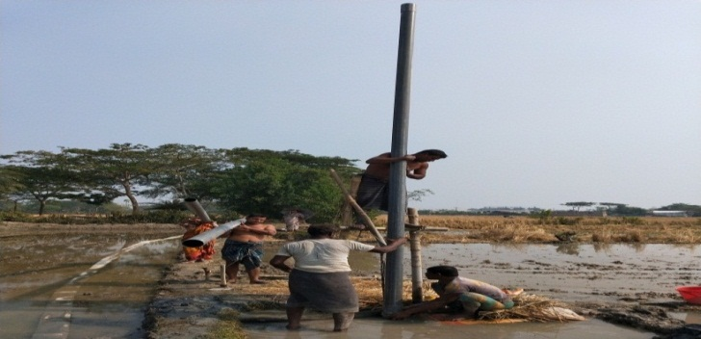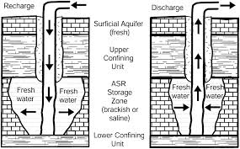

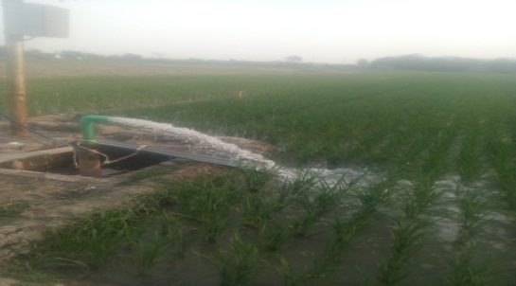

Construction in progress

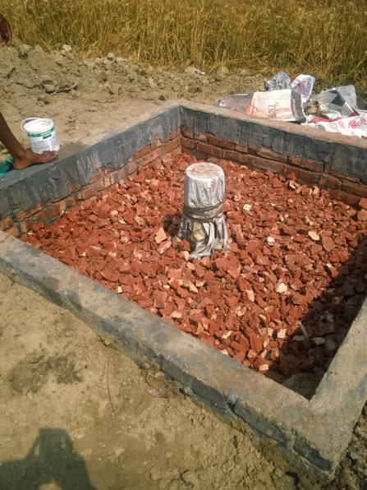

Construction completed

Watering rice field with recharged rainwater.

**Improved Cook Stove:**

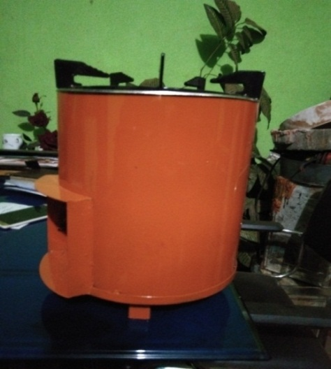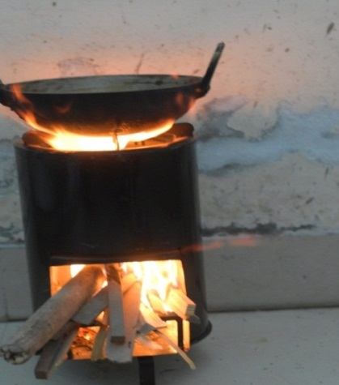 It’s a component of climate mitigation options. The environment friendly cook stove we call it “mobile Chula” can be used during disaster. It needs less fuel, emits less carbon, keeps indoor pollution free, and saves money. Easily transportable it can be used in cyclone shelter and flood shelters.

Mobile Chula

Chula in Operation